Product analysis

- Identity association rules between items that appear jointly in an event
- Identify patterns of products/categories that are most likely to be purchased

Why is the model important?
- Identification of driving products/categories
- Recognizes in advance unknown purchasing patterns, according to customers’ behavior
- Suggests targeted offers (Next Best Offer) based on identified rules
- Allows new contract strategy plan

Algorithms for rules associative
- Discover the hidden associations that exist between different sets of jointly purchased products and services
- Also they allow to identity recurring behaviors among customers
- Associative rule: {x} ⟹ {y} such that if {x} is true then {y} is true
- Analyze transaction made by customers to understand their purchase patterns

Methodological approach related to the association rule
- Dataset D made of n observations O
- Each observation is made by m binary variables that tell the presence or absence of m within the single observation
- Define an associative rule such as x ⟹ y
- Define a support of the associative rule, define as percentage of transaction in the dataset D that contain both x and y
- Define confidence of the associative rule, is P(x|y) aka the percentage of observations containing x which also contains y
- Establish a minimum support value and a minimum confidence value
- Complete a search for the rules that exceed these criteria, called strong association rule

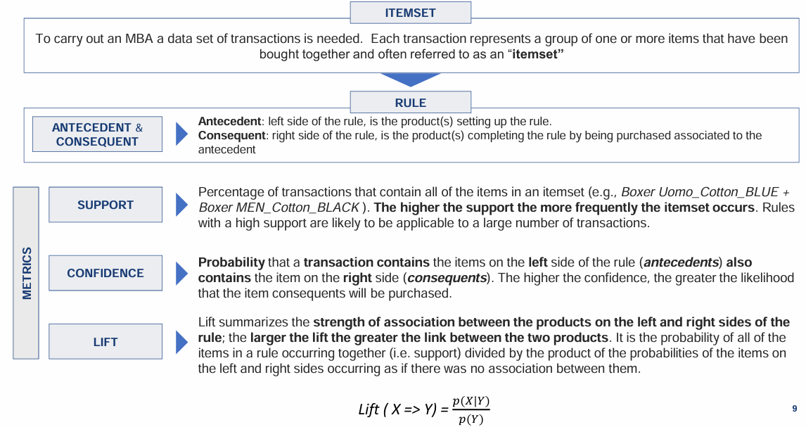

Product Propensity Model
- Supervised ML that allow to identity the probability that a customer will purchase a product
- Identify undecided customers (with lowest probability of purchasing a certain product) to convince them to purchase a product and thus increasing the upselling and cross selling rates

Long sequence of customer’s purchase to estimate the probability of each product to be present in the next purchase. Also can integrate personal data and socio-demographic data to increase accuracy of the model.

